Question 1:
https://www.hackerrank.com/challenges/conditional-statements-in-c/problem
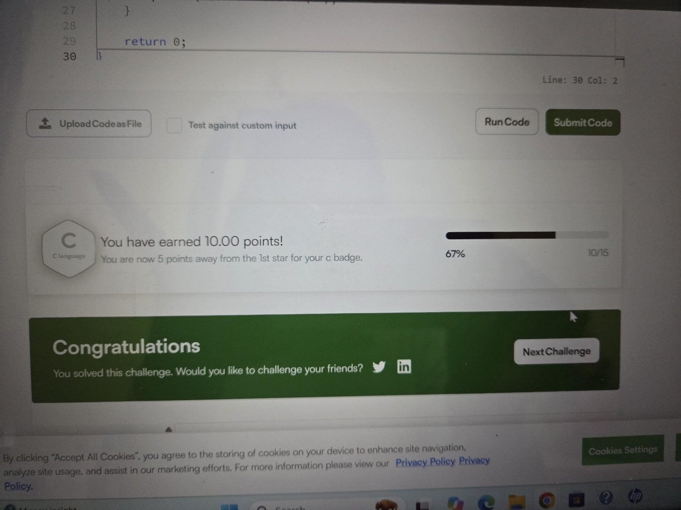
Question 2:
https://leetcode.com/problems/smallest-even-multiple/submissions/2191367051/

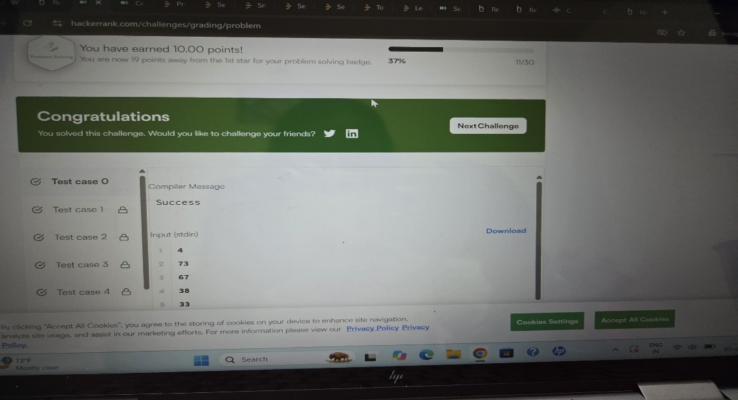
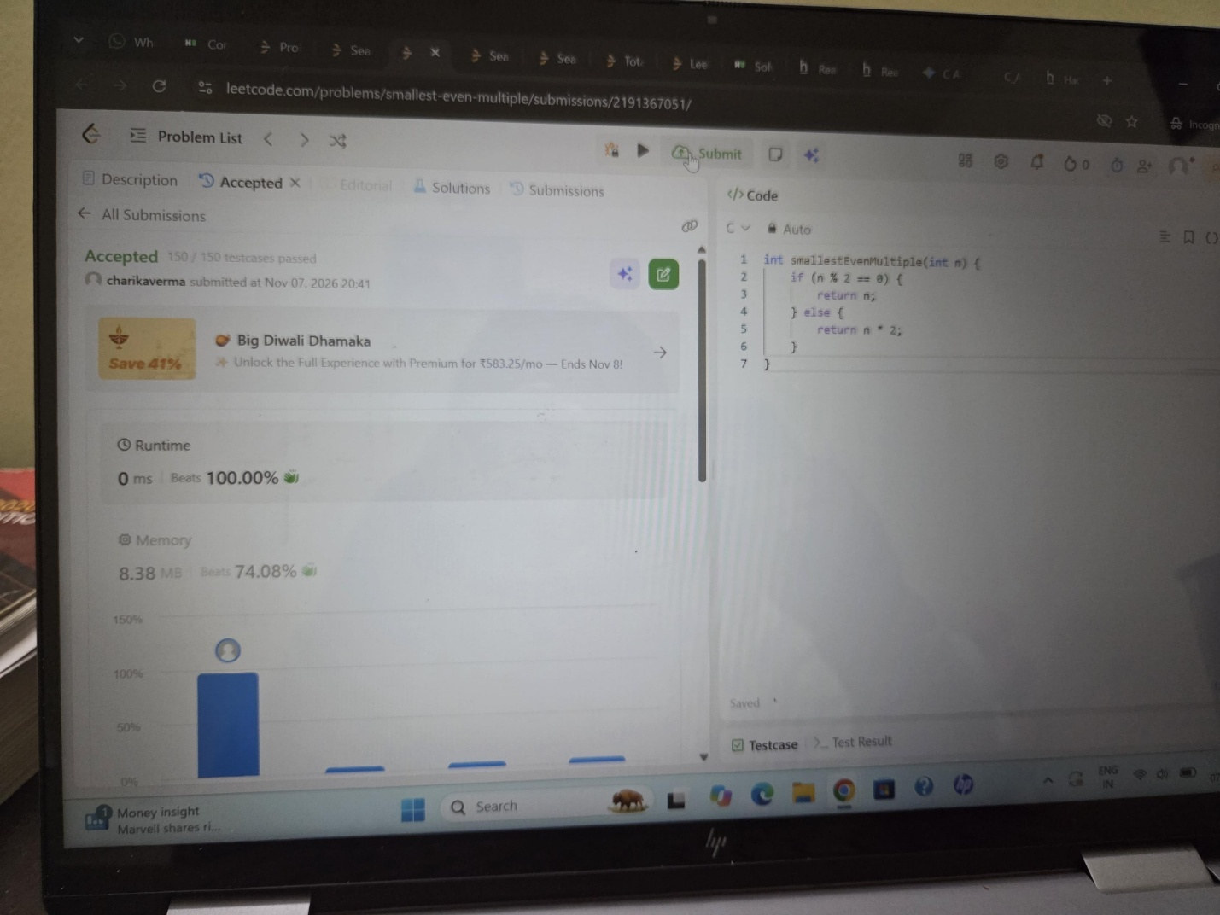

Question 3:
https://www.hackerrank.com/challenges/grading/problem

Question 4:
https://www.hackerearth.com/practice/basic-programming/input-output/basics-of-input-output/practice-problems/algorithm/roy-and-profile-picture/
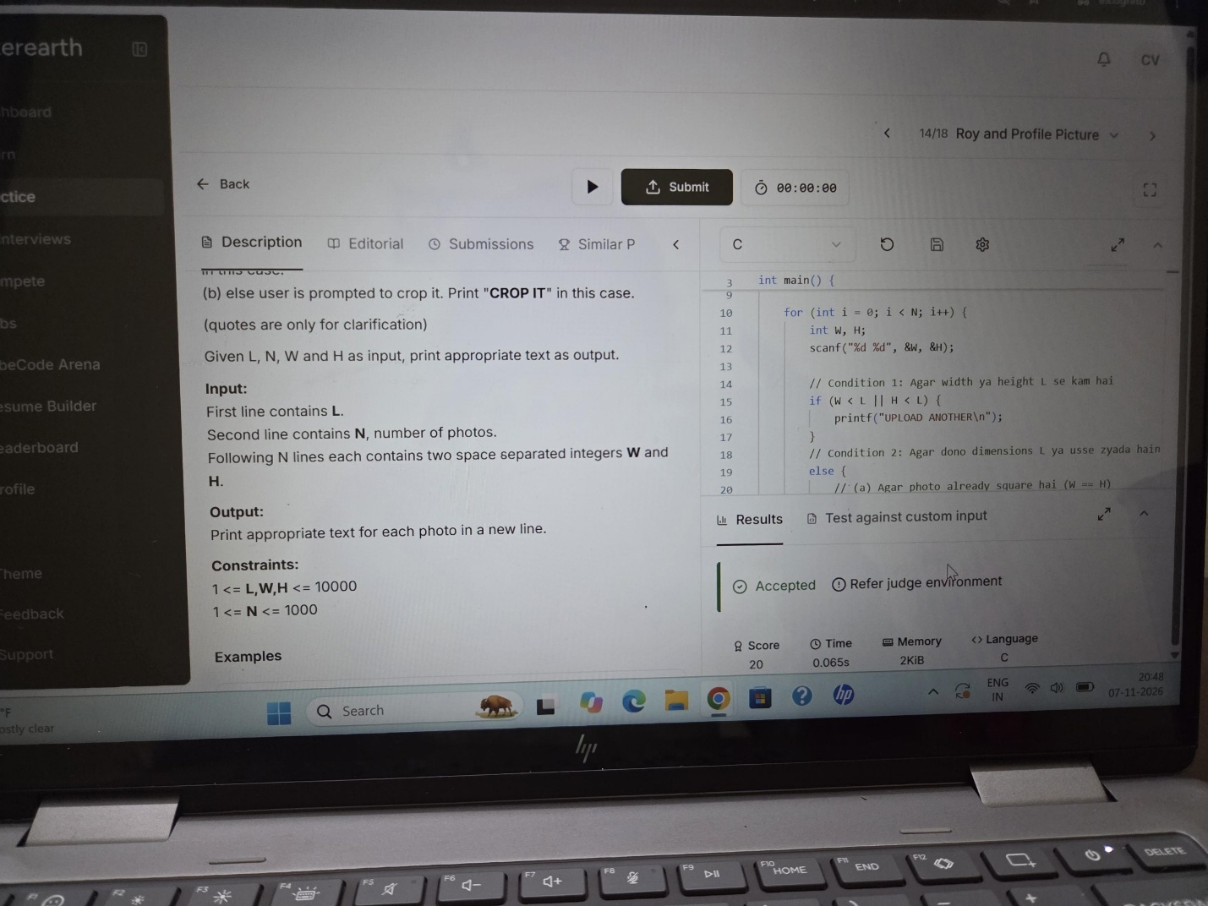
Question 5:
https://www.hackerrank.com/challenges/fizzbuzz/problem



